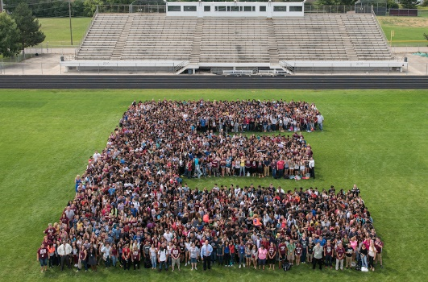

**Level Up**

**Try Everything**

**Give Grace**

**Earn and give respect**

**Hold yourself responsible  
Safety first**

Elgin High School Student Bulletin

Friday April 25th 2025

* 4/25 (Cardenas) Juniors and Seniors, this is the LAST WEEK to get your Prom tickets!!! On sale today AFTER SCHOOL today after school, AND SATURDAY 9am to 11am in room 253 A located by West Commons. Ticket prices are $80. Guest forms must be completed before buying a ticket for a guest! Don't miss Hollywood Glam: A Night on the Red Carpet.
* 4/25 (Cardenas/Verastegui) Congratulations to the following students: Braedyn Tretev; Vivian Vazquez; Danielle Fabian-Perez; and Edward Hernandez; your attendance on Monday, April 14th is being rewarded with a free PROM Ticket. Please see Mr. Cardenas to claim your free ticket.
* 4/25 (Spets) Get your senior trip codes today outside room 246 in the art hallway! See Mrs. Spets or Mr. Stewart with any questions!
* 4/25 (Riddle) One last chance to see this year's Student Directed One Acts and support our Seniors in their final production at Elgin High. The show begins at 7:00 PM tonight in the Elgin High School Auditorium. Tickets are $5 at the door. We hope to see you there!
* 4/25 (Spets/Stewart) Seniors, you should have a received an email to vote on superlatives and your class song. Check your student email for that form, voting closes on Friday, May 2!
* 4/25 (Garcia) Free- Prom Hair & Makeup Services at Elgin High School. Are you preparing for prom and want to look your best? Licensed hairstylists and makeup artists will be available at Elgin High School on Friday, May 2, 2025, to provide complimentary hair and makeup services to students attending prom. To reserve your spot, please scan the QR code on the event flyers posted around the school. For additional information or questions, contact Ms. Garcia. Don’t miss this opportunity to get ready for prom night with professional styling!